**How to access the Instance metadata:**

1. Enter your AWS account Console, [launch a linux instance and connect to it.](http://www.newvem.com/connecting-to-aws-linux-instance-from-a-windows-machine/)
2. To get the Instance metadata run: **GET** [**http://169.254.169.254/latest/meta-data/**](http://169.254.169.254/latest/meta-data/)
3. Run the Linux command **/usr/bin/curl –s** [**http://169.254.169.254/latest/meta-data/**](http://169.254.169.254/latest/meta-data/)
4. It will list the available metadata. If you want specific metadata like ami-id, public-ip or local ip run commands as shown in below image.

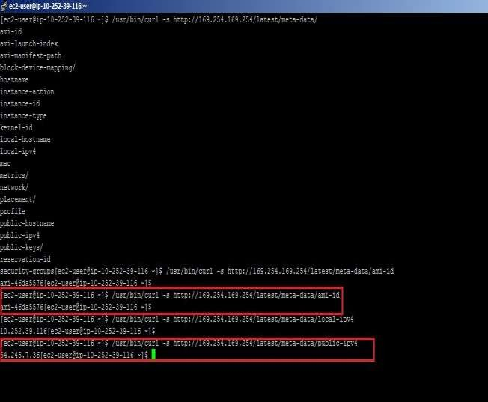

1. A few more samples like get availability zone (here us-west-2b), instance-type (here micro), mac, security group, public host name of running instance is shown below.

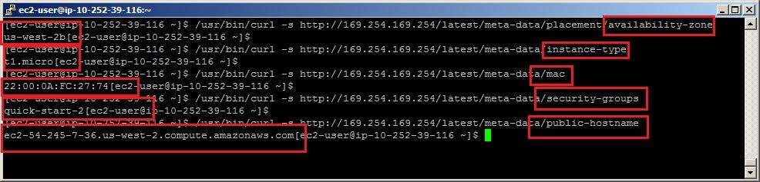

1. You can also run command wget instead of curl to get the instance metadata. Run command

# wget –q –o – [http://169.254.169.254/latest/meta-data/.](http://169.254.169.254/latest/meta-data/)

1. For example if you want to get ami-id using wget, run command

# wget –q –o – <http://169.254.169.254/latest/meta-data/ami-id> to get AMI id.

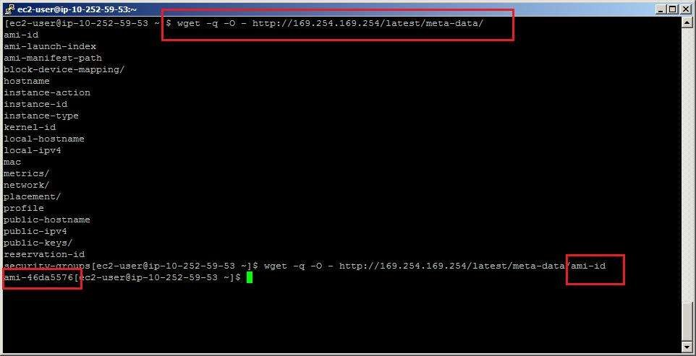

1. If you are in windows, you can run the command as SOAP call in browser or call from the AWS SDK / API.
2. If you type in the browser <http://169.254.169.254/latest/meta-data/>, it will return all the instance metadata.

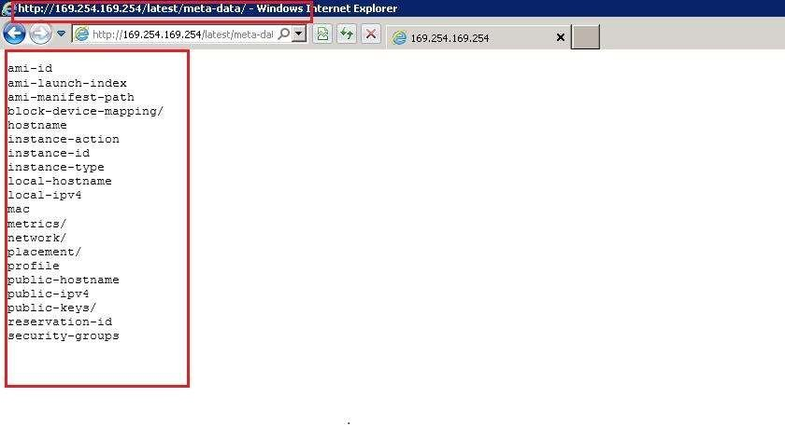

1. Now if you want to query particular data send in the URL that metadata. E.g. If you want to know local IP of instance, type in the browser [http://169.254.169.254/latest/meta-data/local-ipv4.](http://169.254.169.254/latest/meta-data/local-ipv4)

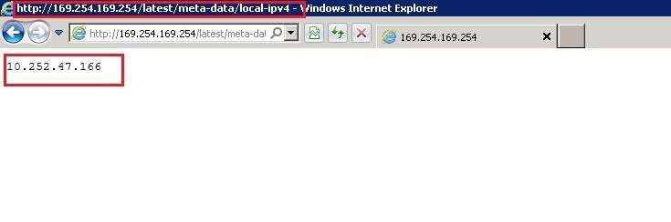

**How to add your own metadata to an instance and get it from instance -**

1. When you launch and instance, it asks to provide the metadata.
2. If it is an EBS backed instance, you can stop the instance and provide the metadata.

h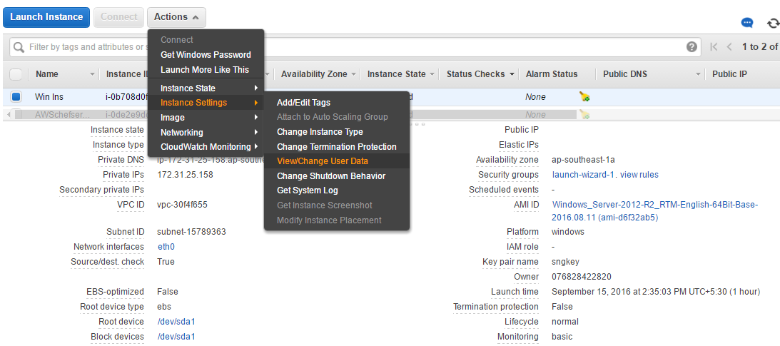

We can view or modify user data here

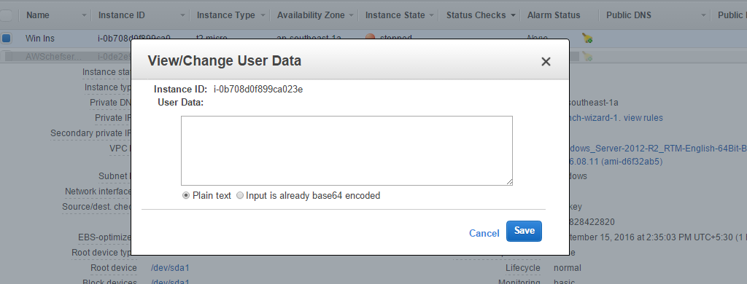

**15.** In order to get the metadata of Linux instance run the following command -

# /usr/bin/curl –s [http://169.254.169.254/latest/meta-data/user-data.](http://169.254.169.254/latest/meta-data/user-data)

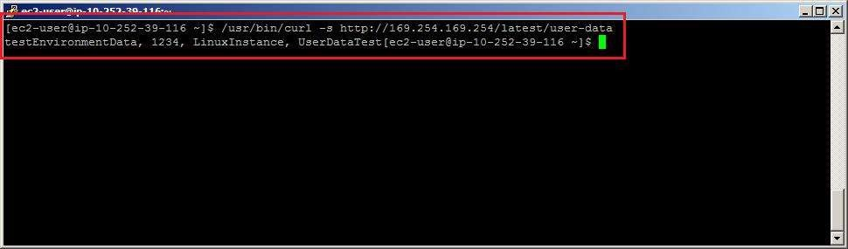

As shown above either you can get instance metadata or your own metadata in the instance. This option is very useful when you want to pass boot parameters or pass some instructions during instance boot. Also when you have to configure DB connection / register your instance with monitoring tool or some configuration management tool the metadata is very handful.